**SimpleBackupUI Details**

<https://github.com/mattmcvay/SimpleBackupUI>

The SimpleBackupUI can help manage the SimpleBackup Service. It gives the user the ability to:

* Turn the service on or off
* Update the source and backup locations
* View the drives attached to the PC
* View a backup log

The only code update that will need to be change is the connection string found in the web.config file, line 11. Change this to reflect the SQL Server AutoBackup database you created for the Simple Backup service.

Screenshots of the UI  
Full Pic:

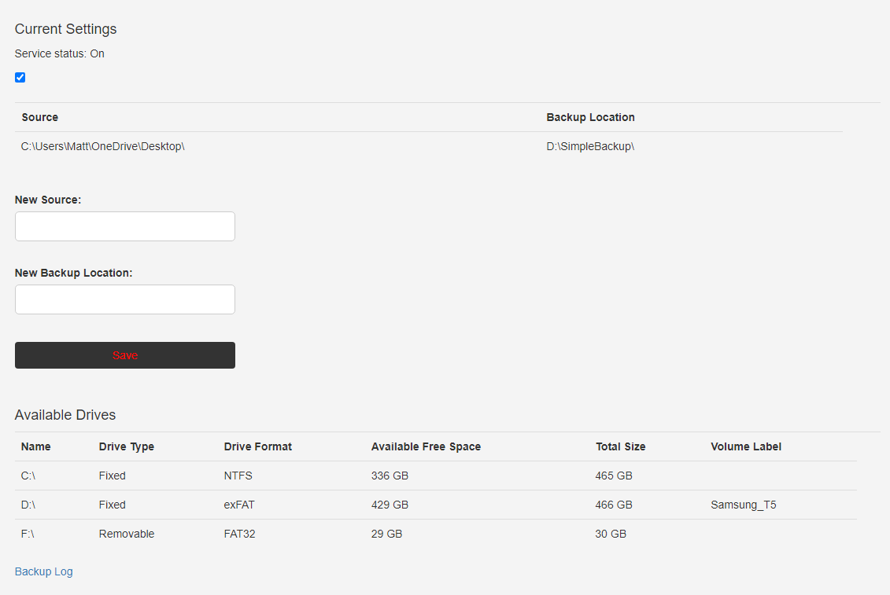

**Current Settings**: As soon as this program runs it checks if the service is running or not, and displays a check in the box if it is and an empty check if it is not. **You can also manually click the check box to turn the service on or off if needed.** When doing so, a Window’s popup may appear… click yes to update the service status.  
  
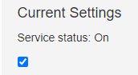

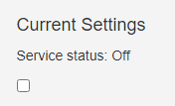

**Source and Backup Location**: The service reads the database values and you can easily update these values by inserting new ones into the textbox and clicking save. After clicking the Save button, if the Source and Backup Locations don’t automatically update, you may need to hit the refresh button on the page to see the updated values in the UI. However, the database values should be updated.

Note: Make sure your source and backup locations end in a back slash when updating => \  
  
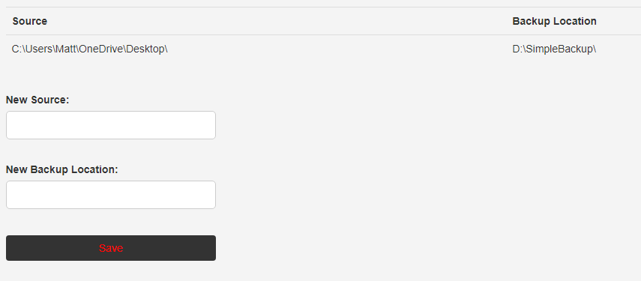

**Available Drives**: Simple shows what drives are attached to the PC.  
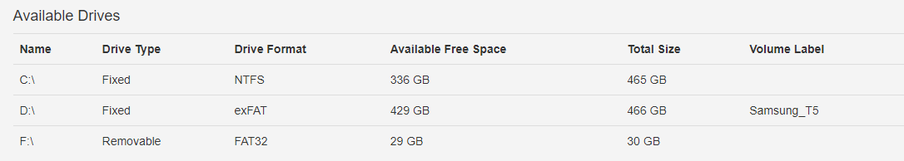

**Backup log**: Takes you to a page to view what has been backed up. Once in the Backup Log page, there is a Back button that takes you back to the home page.

